Dates | Masses | Intentions
Monday 28th
(Feria)

Tuesday 29th  (SS Michael, Gabriel & Raphael, Archangels) | 10.00 am  at Saint Osmund’s, Gainford
Wednesday 30th
(St Jerome,
Priest & Doctor)

Thursday 1st
(St Therese of the Child Jesus, Virgin
& Doctor)
Friday 2nd
(The Holy
Guardian Angels)
Saturday 3rd  (Feria) | 6.30 pm  at Saint  Mary’s | Our Parish  & Congregation

MASS INTENTIONS & OFFERINGS TO
FATHER GRIEVES at
St Osmund’s Catholic Church, Gainford.

FOR YOUR PRAYERS:
The Sick:
Edna, Honia, Graham, Father Elkin, Daniel, Courtney, Chelsea, Joan’ Leslie and John.

Recently Departed:

Father Grieves’ contact details: St Osmund’s Presbytery, Main Road, Gainford, County Durham, DL2 3DZ. 01325 730191 0777 559 1105 ilg5394@gmail.com

ST MARY’S CATHOLIC CHURCH IS
NOW ON SOCIAL MEDIA.
Like our Facebook page:
St. Mary’s Catholic Church,
Barnard Castle
Follow us on Instagram: stmaryscatholicchurchbc
Follow us on Twitter:
@SMCCBarnardC

PLEASE PUT YOUR WEEKLY ALMSGIVING THROUGH THE PRESBYTERY LETTER-BOX. THIS IS AN URGENT & IMPORTANT REQUEST.

St Aidan, St Anne, St Augustine, Holy Family, St Mary
Hogarth Partnership
St Osmund, St Teresa, St Thomas & St William

St Mary’s Catholic Church,
Barnard Castle & St Aidan’s Catholic Church,
Middleton in Teesdale

WEEKLY BULLETIN
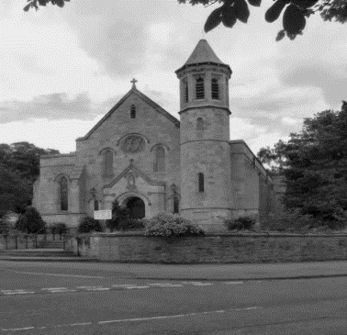

Saturday 26th September 2020
26th SUNDAY OF THE YEAR (A)
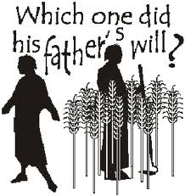
Christ came to forgive sinners.
We are all in need of God’s forgiveness and it was for this reason that Christ came, humbling himself to accept death on the cross. When we renounce sin we will truly live. We are all called to put the needs of others before our own, and never to take our place in God’s kingdom for granted.

ST MARY’S CATHOLIC CHURCH WILL
RE-OPEN on Saturday 3rd October at
6.30 pm and on Thursday 8th October at
10.00 am, and each subsequent Saturday and Thursday. To ensure proper social distancing the capacity of the church is reduce to 28 people, and to comply with the requirement for Track and Trace it will be necessary to book a place at all Masses. For the 6.30 pm Parish Vigil Mass & 10.00 am Thursday Mass please CALL or TEXT 07385 175872. Please provide your name, day & time you wish to attend, number of individuals and a contact phone number.
Making an Act of Spiritual Communion while prevented from receiving the Blessed Sacrament.
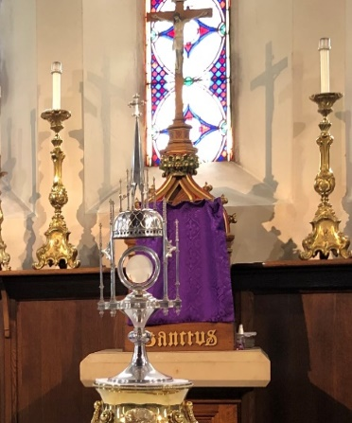
My Jesus,
I believe that You are present in the Most Holy Sacrament.
I love You above all things,
and I desire to receive You
into my soul.
Since I cannot at this moment receive You sacramentally,
come at least spiritually into my heart.
I embrace You as if You
were already there
and unite myself wholly to You.
Never permit me to be
separated from You.
Amen.

Counselling and Listening Services
As part of the pastoral care of parishioners and others during this COVID-19 lockdown, a number of qualified counsellors and listeners have generously made themselves available to anyone who may be troubled by the negative effects of the situation. These counsellors and listeners can be contacted through the St Mary’s Cathedral Listening Service on 0191 232 6953 and the Northumberland Listening Service
on 07732 980740.

Live streamed services
this week include:
In our Hogarth Partnership from
St. Augustine’s at 9.15 am; on their
Facebook page: www.facebook.com/staugustineschurchdarlington
Daily Mass and other services can be found on many other sites including:
Diocese of Hexham and Newcastle: www.rcdhn.org.uk
Walsingham live: www.walsingham.org.uk
Vatican https://www.youtube.com/channel/
UCxIsefyl9g9A5SGWA4FvGIA
Other Churches throughout the UK and Ireland:
www.churchservices.tv/whats-on-now

NOTES ON RETURNING
TO CHURCH
- Those who are clinically extremely vulnerable or clinically vulnerable including those over 70, are advised to stay at home as much as possible and, if they do go out, to take particular care to minimise contact with others outside of their household.
- If you suspect that you have Covid-19, (high temperature, new persistent cough, lack of taste or smell) or if you are living with someone who has or is suspected of having Covid-19, you MUST self-isolate in accordance with HM Government guidance and contact the online 111 service to arrange for testing.
- If you have returned from overseas you should review the latest guidance from the Foreign and Commonwealth Office.
- If you test positive for Covid-19 after having recently attended church, you MUST contact your Parish Priest.
- Please make sure you sanitise your hands as you come into church.
- The Government require all those worshipping in church to wear a face covering.
- Only sit where directed by the stewards. When coming forward for Holy communion please follow the directions of the stewards remove your face covering and sanitise your hands just before receiving the Blessed Sacrament. Please keep to social distancing.
- Please leave in silence by the side door at the front of church.

Churches are beginning to re-open, but it is important to stress that no-one should feel any compulsion to return to church. We are ‘treading carefully’ and Sunday obligation remains suspended. Keep well and stay safe.

AN ADVANCED DATE
FOR YOUR 2021 DIARY:
WORLD DAY OF PRAYER
Friday 5th March
10.30 am for 11.00 am at
St Mary’s Catholic Church,
Barnard Castle.
EVERYONE IS WELCOME

