Dates | Masses | Intentions
Monday 22nd  (SS John Fisher & Thomas More, Martyrs) |  | Derek  Mais,, RIP  (Year’s Mind)
Tuesday 23rd  (St Etheldreda, Abbess) |  | Michael Bacon, RIP (on the occasion of his Funeral)
Wednesday 24th  (The Nativity of John the Baptist) |  | Norman Tweedley (for his health and well-being)
Thursday 25th  (Feria) |  | Father Elkin  (for his health and well-being)
Friday 26th  (Feria) |  | Geoff  Starr, RIP  (Year’s Mind)
Saturday 27th  (Saturday Mass  of Our Lady) |  | Mena  Bowman, RIP  (Year’s Mind)

MASS INTENTIONS & OFFERINGS TO
FATHER GRIEVES at
St Osmund’s Catholic Church, Gainford.

FOR YOUR PRAYERS:
The Sick:
Honia Devlin, Graham Smith, Father Elkin, Daniel Dougherty, Courtney Dougherty, Chelsea Johnson, Jack Nugent, Joan Johnson, Leslie Burgess and John Burgess.

Recently Departed: John Farrell, Michael Bacon, Dennis Connelly, RIP

Father Grieves’ contact details: St Osmund’s Presbytery, Main Road, Gainford, County Durham, DL2 3DZ. 01325 730191 0777 559 1105 ilg5394@gmail.com

ST MARY’S CATHOLIC CHURCH IS
NOW ON SOCIAL MEDIA.
Like our Facebook page:
St. Mary’s Catholic Church,
Barnard Castle
Follow us on Instagram: stmaryscatholicchurchbc
Follow us on Twitter:
@SMCCBarnardC

PLEASE PUT YOUR WEEKLY ALMSGIVING THROUGH THE PRESBYTERY LETTER-BOX. THIS IS AN URGENT &
IMPORTANT REQUEST

St Aidan, St Anne, St Augustine, Holy Family, St Mary
Hogarth Partnership
St Osmund, St Teresa, St Thomas & St William

St Mary’s Catholic Church,
Barnard Castle & St Aidan’s Catholic Church,
Middleton in Teesdale

WEEKLY BULLETIN
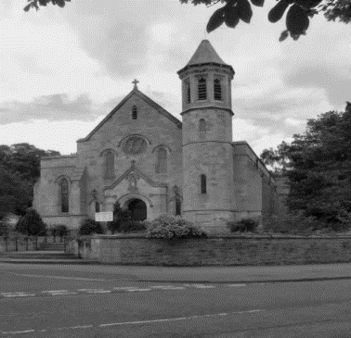

Saturday 27th June 2020
12th SUNDAY OF THE YEAR

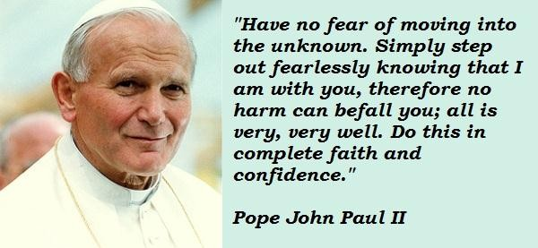

Do not be afraid.
We have no need to be afraid since God is always at our side supporting and strengthening us in times of weakness and temptation. The evil effects of sin are swallowed up in the victory of Christ. He gives life to our souls and with him we have no cause for fear.

ST MARY’S CATHOLIC CHURCH
CLOSED UNTIL FURTHER NOTICE

MASS INTENTIONS & OFFERINGS
TO FATHER GRIEVES.
Mass is offered daily in
St Osmund’s, Gainford.

Making an Act of Spiritual Communion while prevented from receiving the Blessed Sacrament.
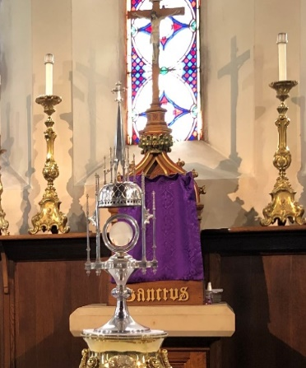
My Jesus,
I believe that You are present in the Most Holy Sacrament.
I love You above all things,
and I desire to receive You
into my soul.
Since I cannot at this moment receive You sacramentally,
come at least spiritually into my heart.
I embrace You as if You
were already there
and unite myself wholly to You.
Never permit me to be
separated from You.
Amen.

Counselling and Listening Services
As part of the pastoral care of parishioners and others during this COVID-19 lockdown, a number of qualified counsellors and listeners have generously made themselves available to anyone who may be troubled by the negative effects of the situation. These counsellors and listeners can be contacted through the St Mary’s Cathedral Listening Service on 0191 232 6953 and the Northumberland Listening Service
on 07732 980740.

Live streamed services
this week include:
In our Hogarth Partnership from
St. Augustine’s at 9.15 am; on their
Facebook page: www.facebook.com/staugustineschurchdarlington
Daily Mass and other services can be found on many other sites including:
Diocese of Hexham and Newcastle: www.rcdhn.org.uk
Walsingham live: www.walsingham.org.uk
Vatican https://www.youtube.com/channel/
UCxIsefyl9g9A5SGWA4FvGIA
Other Churches throughout the UK and Ireland:
www.churchservices.tv/whats-on-now

REOPENING CHURCHES
At present, Government regulations allow the opening of churches for private prayer from 15th June. Bishop Robert and the Diocese have reopened of some of our churches, taking into account:
•The safety of parishioners, volunteers, staff and clergy to be the highest priority.
• A very small number of churches will be opened first as a pilot*.
• A full risk assessment will be carried out on each church by the Diocese to ensure health and safety.
• The Diocese will provide the necessary equipment for a deep clean of the churches, and for essential regular cleaning.
• Volunteers will be needed for church cleaning, and as stewards to ensure social distancing when the church is open.
• Full compliance with Diocesan health and safety regulations and procedures will be required by clergy, employees and volunteers before a church is opened.

*pilot churches’ in the diocese that would be ready to be open for private prayer - the plan is that the five churches listed below, one from each Vicariate, would open as soon as is practicable following all necessary risk assessment and health and safety considerations. Then, hopefully, after a short trial period other would follow. St Aidan’s, Ashington, St Mary’s Cathedral, Newcastle, St Patrick’s, Consett, St Mary’s, Sunderland St Joseph’s, Hartlepool.

ST MARY’S PARISH COUNCIL MEETING
Tuesday 30th June 2020 at 7.00 pm by ZOOM – to discuss a reopening plan for St Mary’s Church.
Volunteers from the parish willed be need for church cleaning, and as acting as stewards to ensure social distancing when then church is open – names to John Crabbe and Nadia Earl.

